1.Create one VPC, with 1 public subnet and 1 private subnet
Objective
The objective of this task is to create a secure and organized network infrastructure in AWS using one VPC with one public subnet and one private subnet. The public subnet is used for resources that require internet access, such as web servers, while the private subnet is used for secure internal resources like databases or backend servers. This setup helps in improving security, network management, and resource separation inside the AWS cloud environment.
Explanation
To complete this task, a VPC is first created with a CIDR block such as 10.0.0.0/16, which acts as the main private network in AWS. Inside this VPC, two subnets are created: a public subnet with CIDR 10.0.1.0/24 and a private subnet with CIDR 10.0.2.0/24. The public subnet is configured with an Internet Gateway and a route table containing the route 0.0.0.0/0 so that resources inside it can communicate with the internet. Auto-assign public IP is also enabled for the public subnet. The private subnet is not connected to the Internet Gateway, which ensures that resources inside it remain private and inaccessible directly from the internet.
Validation
The setup can be validated by checking that the VPC and both subnets are in the “Available” state in the AWS console. The Internet Gateway should show the status “Attached” to the VPC, and the route table associated with the public subnet should contain the route 0.0.0.0/0 → Internet Gateway. When an EC2 instance is launched in the public subnet, it should receive a public IP address and have internet connectivity. An EC2 instance launched in the private subnet should not receive a public IP and should not have direct internet access, confirming that the public and private subnet configuration is working correctly.

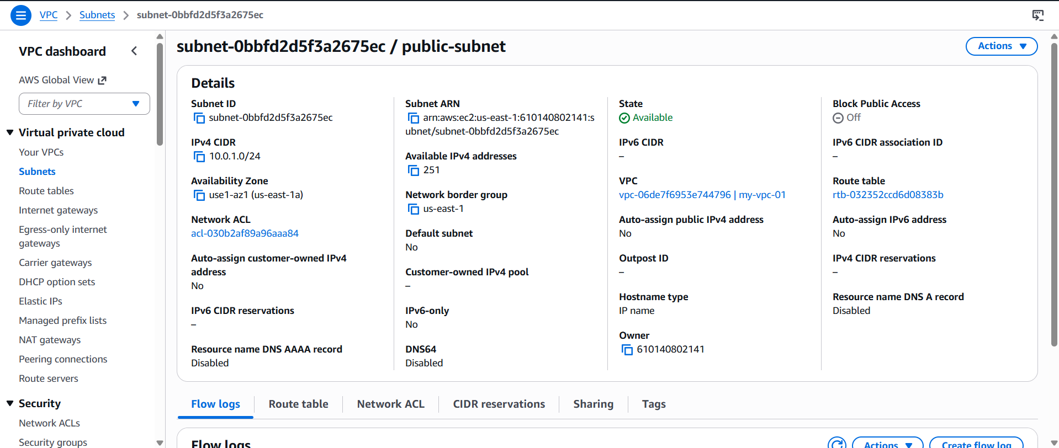
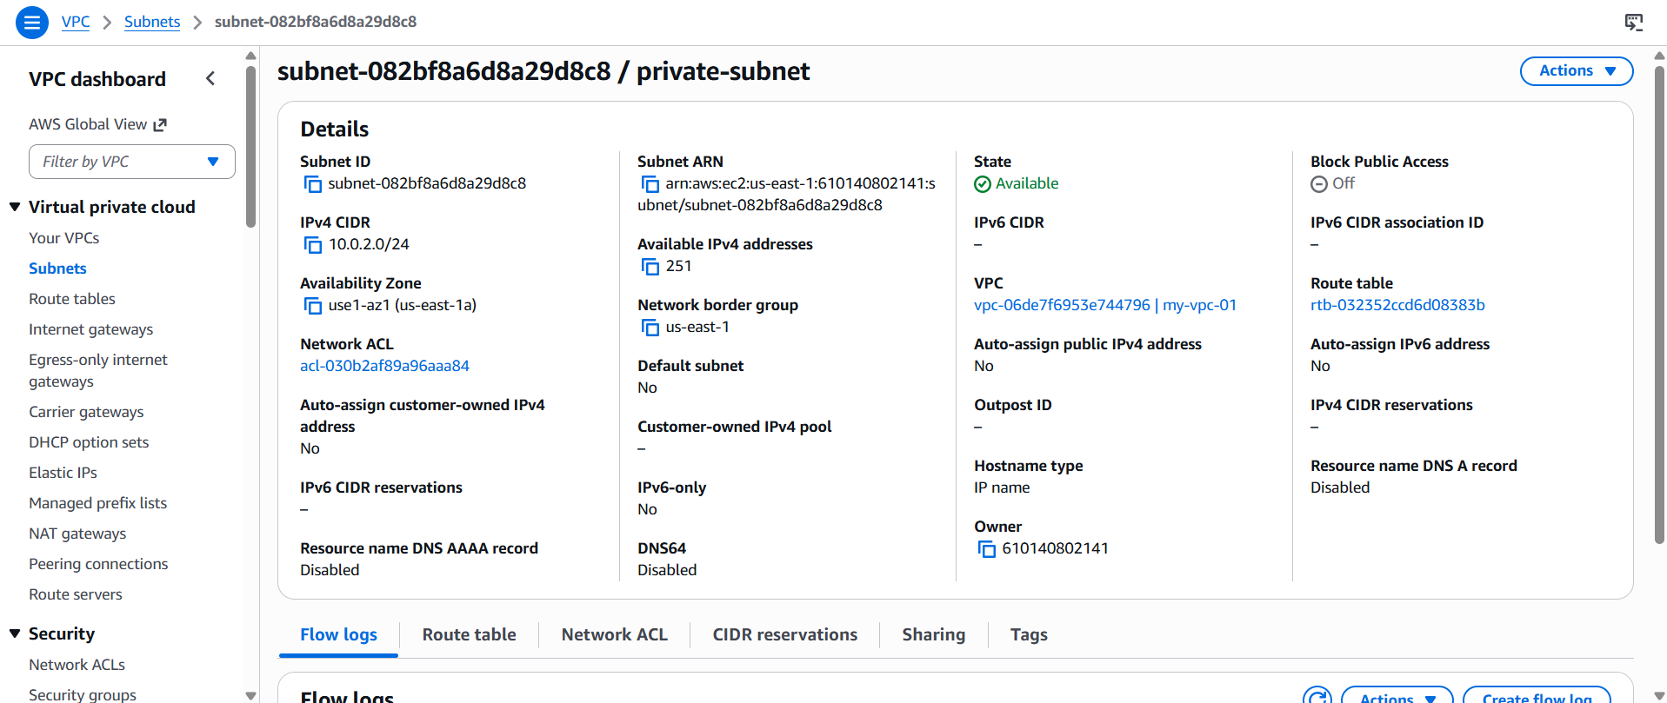

2. Enable VPC peering for cross-region
Objective
The objective of this task is to establish communication between two VPCs located in different AWS regions using VPC Peering. Cross-region VPC peering allows resources in separate VPCs to communicate privately using AWS’s internal network without using the public internet. This is useful for connecting applications, databases, or services deployed across multiple AWS regions securely and efficiently.
Explanation
To configure cross-region VPC peering manually in AWS, first create two VPCs in different regions with non-overlapping CIDR blocks, for example one VPC in Mumbai region (10.0.0.0/16) and another VPC in Virginia region (192.168.0.0/16). After creating the VPCs, open the AWS VPC Console and go to the Peering Connections section. Create a new peering connection by selecting one VPC as the requester and the other VPC from a different region as the accepter. Once the request is created, switch to the accepter region and accept the peering request.
After the peering connection becomes active, update the route tables in both VPCs. In the first VPC route table, add a route pointing the second VPC CIDR block to the peering connection. Similarly, in the second VPC route table, add a route pointing the first VPC CIDR block to the same peering connection. Security groups should also be updated to allow inbound traffic from the opposite VPC CIDR range. This configuration enables private communication between resources in both regions through AWS’s internal network.
Validation
The setup can be validated by checking that the VPC peering connection status is shown as “Active” in the AWS console. The route tables in both VPCs should contain routes pointing to the peering connection for the opposite VPC CIDR block. Security groups should allow traffic from the peer VPC network. Final validation can be done by launching EC2 instances in both VPCs and testing connectivity using private IP addresses with commands such as ping or ssh. Successful communication confirms that cross-region VPC peering is configured correctly.
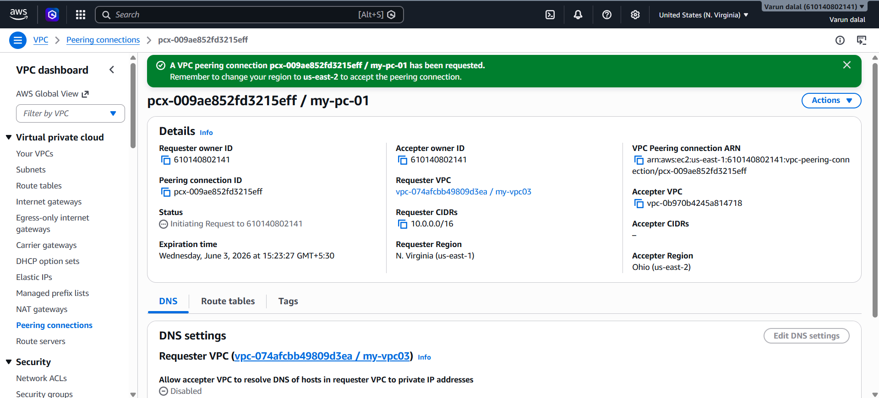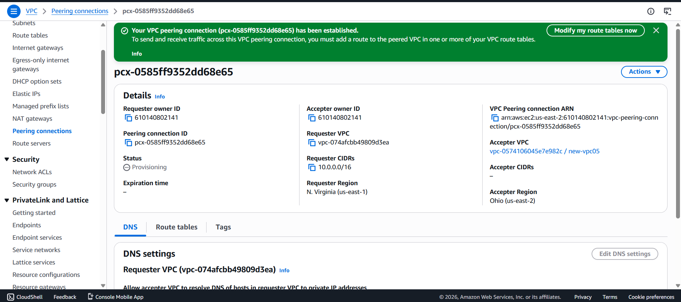
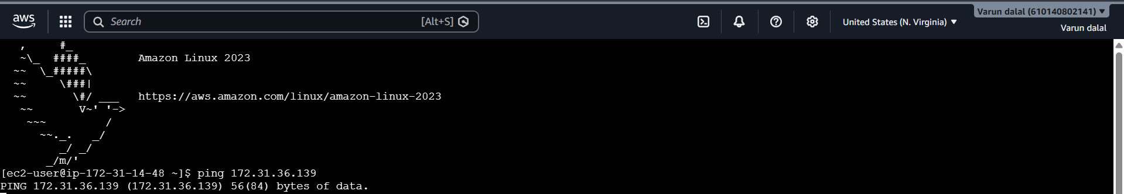

3.Enable VPC peering for cross-account (you can collaborate with your friend to do this task).
Objective
Enable VPC Peering between two AWS accounts so that resources in one VPC can communicate privately with resources in another VPC using private IP addresses.
Prerequisites
Account A
- AWS Account A access
- VPC-A (Example CIDR: 10.0.0.0/16)
Account B
- AWS Account B access
- VPC-B (Example CIDR: 192.168.0.0/16)
Important: CIDR ranges must not overlap.
Step 1: Get Account B Details
In Account B:
- Open VPC Dashboard.
- Go to Your VPCs.
- Copy:
  - VPC ID (Example: vpc-123456)
  - AWS Account ID
Share these details with Account A.
Step 2: Create Peering Connection from Account A
- Login to AWS Account A.
- Open VPC Dashboard.
- Click Peering Connections.
- Click Create Peering Connection.
- Enter:
  - Name: Cross-Account-Peering
  - Requester VPC: Select VPC-A
  - Account: Another Account
  - Accepter Account ID: Account B ID
  - Accepter VPC ID: VPC-B ID
- Click Create Peering Connection.
Status will show Pending Acceptanc
Step 3: Accept Peering Request in Account B
- Login to AWS Account B.
- Open VPC Dashboard → Peering Connections.
- Select the pending request.
- Click Actions → Accept Request.
- Confirm acceptance.
Status changes to Active.
Step 4: Update Route Table in Account A
- Open Route Tables.
- Select the route table associated with VPC-A.
- Click Routes → Edit Routes.
- Add:
Destination | Target
192.168.0.0/16 | Peering Connection ID
- Save changes.
Step 5: Update Route Table in Account B
- Open Route Tables.
- Select the route table associated with VPC-B.
- Click Routes → Edit Routes.
- Add:
Destination | Target
10.0.0.0/16 | Peering Connection ID
- Save changes.
Step 6: Configure Security Groups
In Account A EC2 Security Group
Add inbound rule:
Type | Protocol | Port | Source
All ICMP | ICMP | N/A | 192.168.0.0/16
In Account B EC2 Security Group
Add inbound rule:
Type | Protocol | Port | Source
All ICMP | ICMP | N/A | 10.0.0.0/16
For application traffic, also allow required ports such as:
- SSH (22)
- HTTP (80)
- HTTPS (443)
- Validation Output
- Check Peering Status
- VPC → Peering Connections
- Expected:
- Status: Active

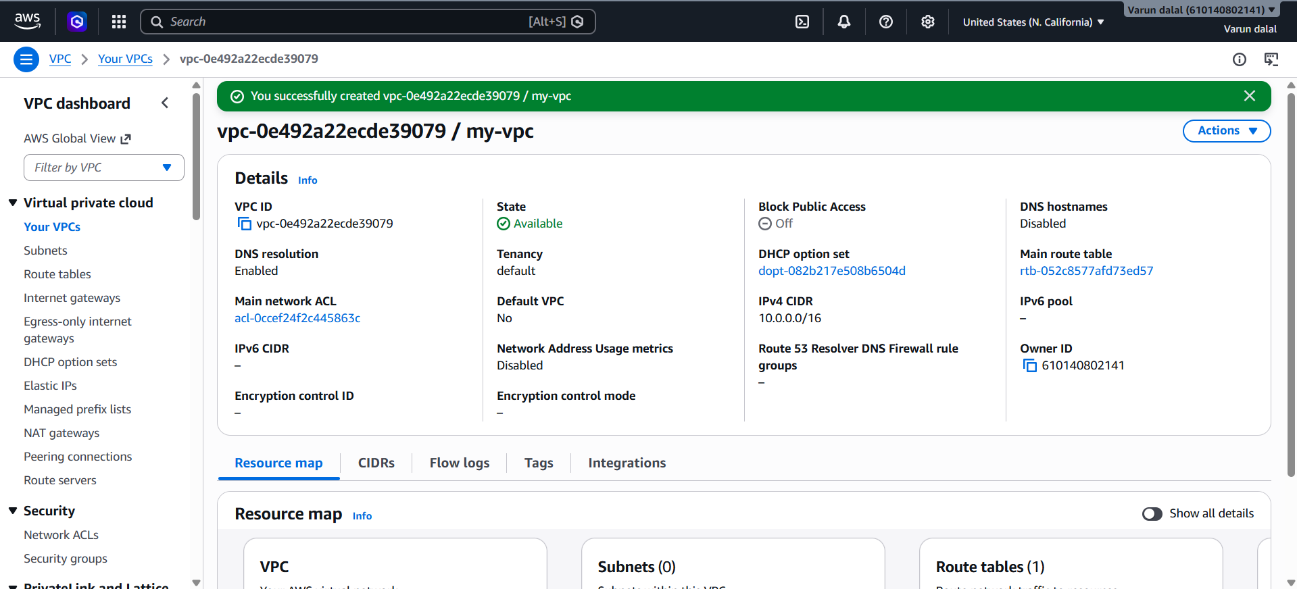
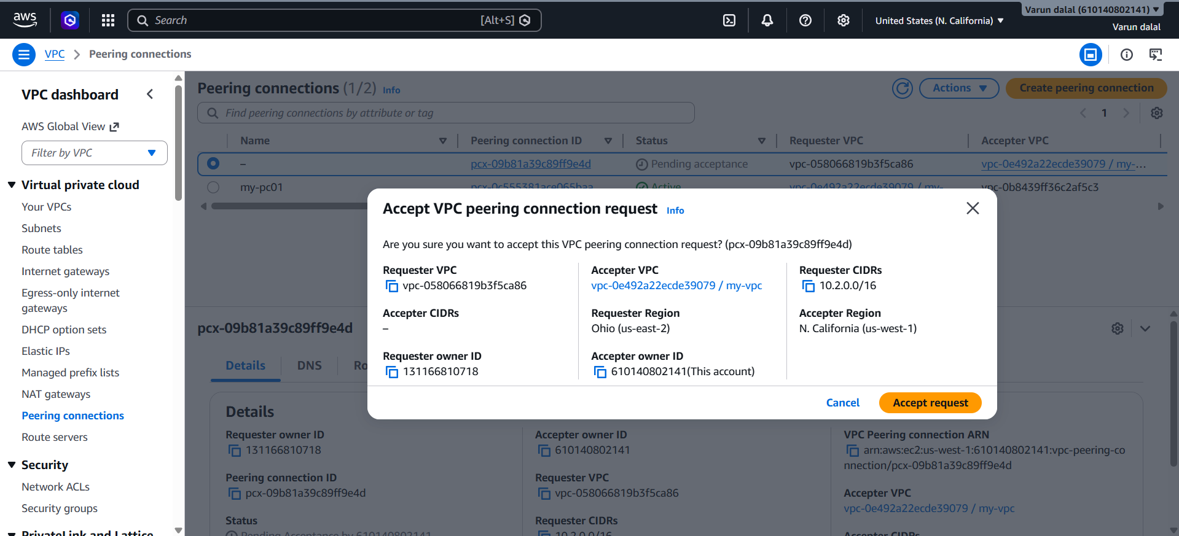

4.Set up a VPC Transit Gateway.
Objective
Create a Transit Gateway (TGW) — a central network hub that connects multiple VPCs and on-prem networks through a single gateway, replacing complex full-mesh VPC peering
Step 1: Create a Transit Gateway
- Login to AWS Console.
- Open VPC Dashboard.
- Click Transit Gateways.
- Click Create Transit Gateway.
- Enter:
  - Name: My-Transit-Gateway
  - Description: Central Hub
- Leave default settings.
- Click Create Transit Gateway.
Validation
Go to Transit Gateways and verify:
Step 2: Create VPCs (if not already created)
Example:
VPC-1
CIDR: 10.0.0.0/16
VPC-2
CIDR: 192.168.0.0/16
VPC-3
CIDR: 172.16.0.0/16
Make sure CIDR ranges do not overlap.
Step 3: Attach VPC-1 to Transit Gateway
- Open Transit Gateway Attachments.
- Click Create Transit Gateway Attachment.
- Select:
  - Attachment Type: VPC
  - Transit Gateway: My-Transit-Gateway
  - VPC: VPC-1
- Select the subnet that will participate.
- Click Create Attachment.
Validation
State: Available
Step 4: Attach VPC-2
- Create another attachment.
- Select:
  - Same Transit Gateway
  - VPC-2
- Select subnet.
- Create attachment.
Validation
State: Available
Step 5: Attach VPC-3
- Create another attachment.
- Select:
  - Same Transit Gateway
  - VPC-3
- Select subnet.
- Create attachment.
Validation
State: Available
Step 6: Update Route Tables in VPC-1
Open Route Table of VPC-1.
Add routes:
Destination | Target
192.168.0.0/16 | Transit Gateway
172.16.0.0/16 | Transit Gateway
Save changes.
Step 7: Update Route Tables in VPC-2
Add:
Destination | Target
10.0.0.0/16 | Transit Gateway
172.16.0.0/16 | Transit Gateway
Save changes.
Step 8: Update Route Tables in VPC-3
Add:
Destination | Target
10.0.0.0/16 | Transit Gateway
192.168.0.0/16 | Transit Gateway
Save changes.
Step 9: Verify Transit Gateway Route Table
- Open Transit Gateway Route Tables.
- Select the default route table.
- Click Routes.
- Step 10: Configure Security Groups
- Allow ICMP (Ping) between VPC CIDRs.
- Example:
Type | Source
All ICMP | 10.0.0.0/16
All ICMP | 192.168.0.0/16
All ICMP | 172.16.0.0/16
Step 11: Launch EC2 Instances
Launch one EC2 instance in each VPC.
Step 12: Validate Connectivity
From EC2 in VPC-1:
ping 192.168.1.10
ping 172.16.1.10
From EC2 in VPC-2:
ping 10.0.1.10
From EC2 in VPC-3:
ping 10.0.1.10
Expected Output
Transit Gateway
Transit Gateway State: Available
Result
All VPCs communicate through a single Transit Gateway, eliminating the need for multiple VPC peering connections and simplifying network management.
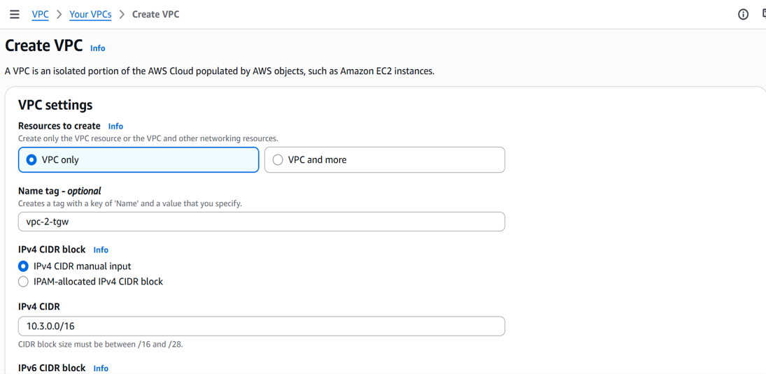
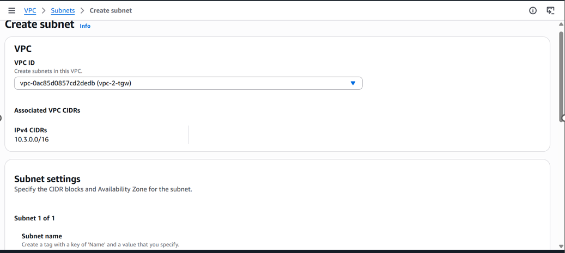
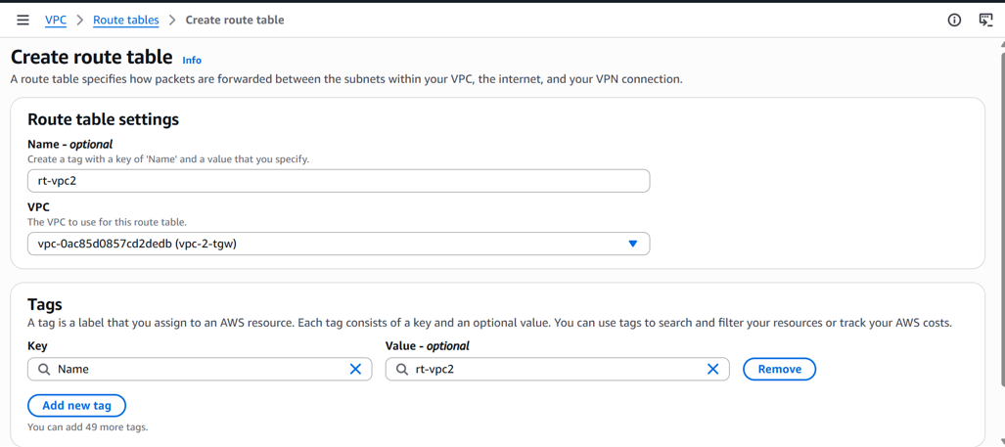
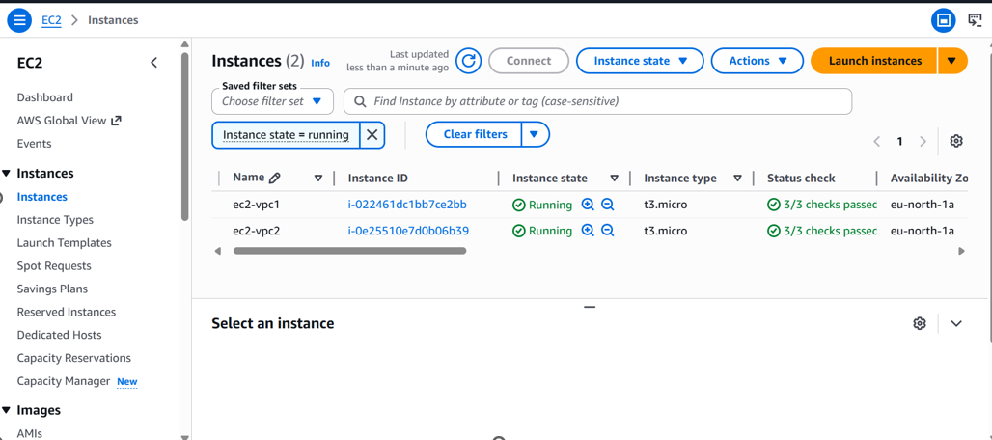
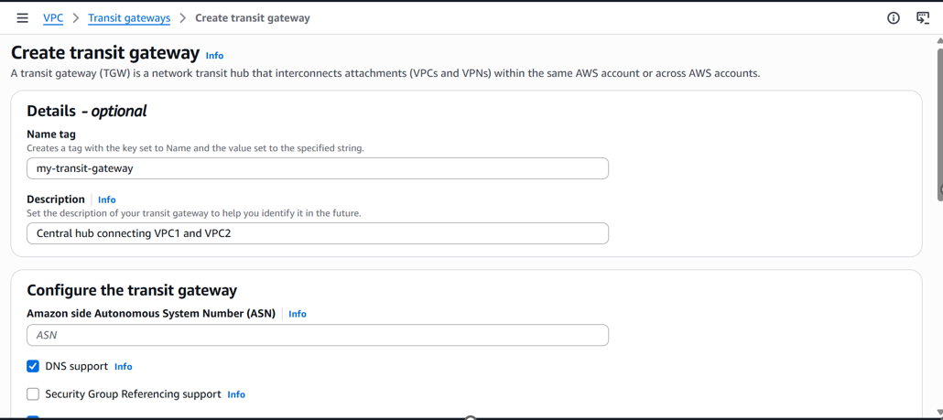
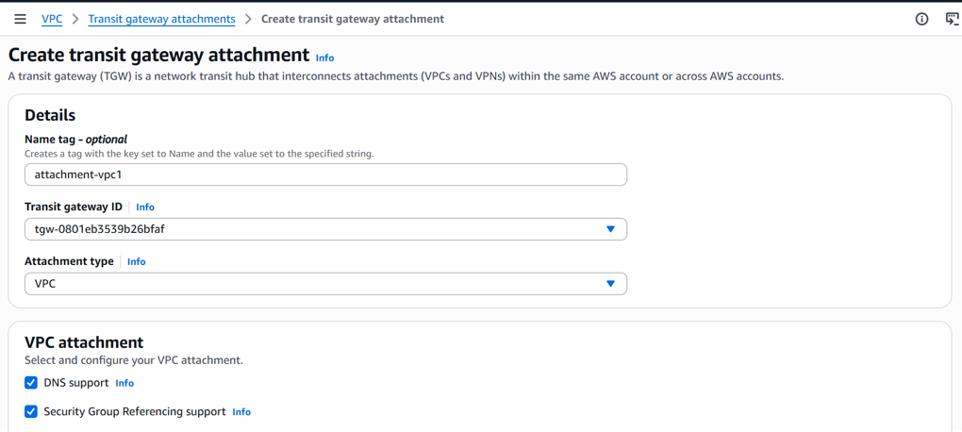
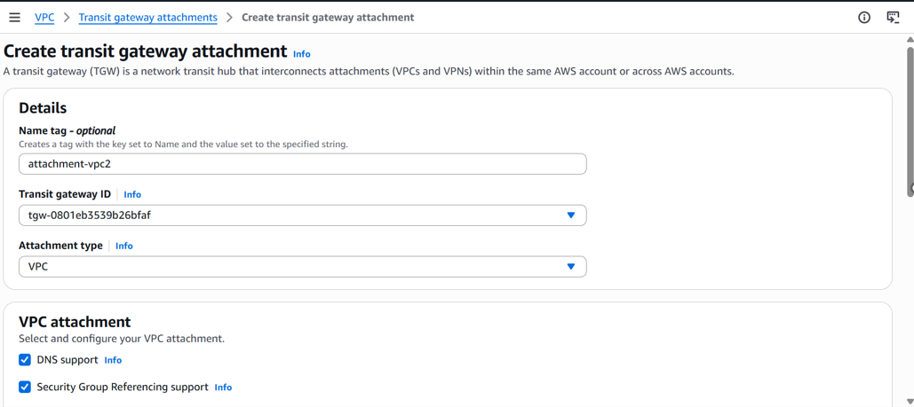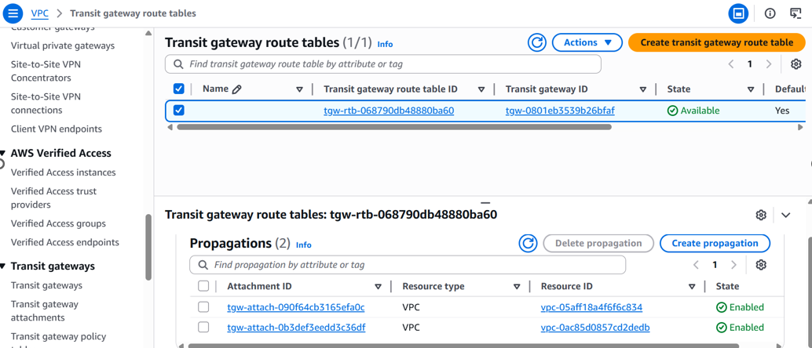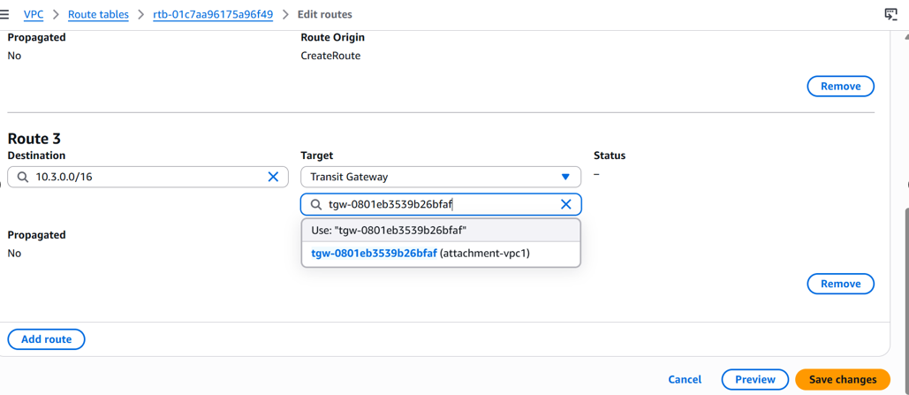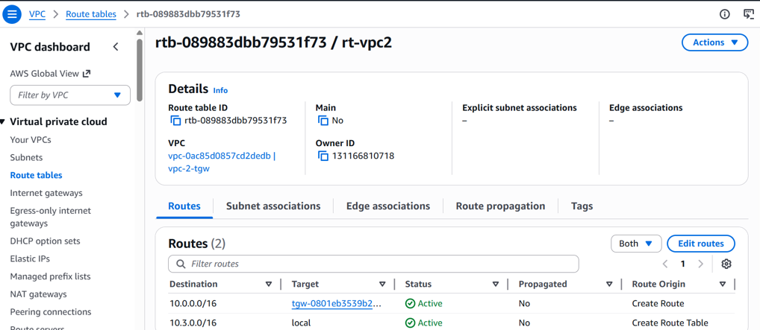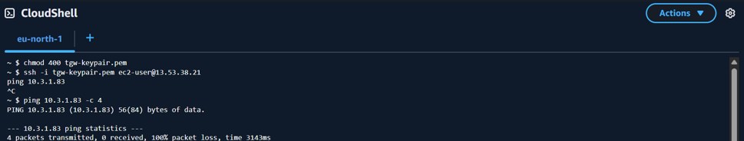

5.Set up a VPC Endpoint
Objective
Create a VPC Endpoint so that resources inside your private subnet can access AWS services (like S3, DynamoDB) without going through the internet — staying entirely within AWS's private network.
Steps
Step 1 — Create an IAM Role for EC2 (to access S3)
- Go to IAM → Roles → Create Role
- Trusted entity: EC2
- Attach policy: AmazonS3ReadOnlyAccess
- Name: ec2-s3-role
- Create Role
Step 2 — Attach the Role to your Private EC2
- Go to EC2 → Instances → Select your private EC2
- Actions → Security → Modify IAM Role
- Attach ec2-s3-role
Step 3 — Create the VPC Endpoint (Gateway for S3)
- Go to VPC → Endpoints → Create Endpoint
- Fill in:
  - Name: s3-gateway-endpoint
  - Service category: AWS Services
  - Search for: s3
  - Select: com.amazonaws.ap-south-1.s3 (Gateway type)
  - VPC: my-custom-vpc
  - Route Tables: ✅ Select BOTH public-rt and private-rt
  - Policy: Full Access (default)
- Click Create Endpoint
Step 4 — Verify Route Table Updated Automatically
- Go to VPC → Route Tables → open private-rt
- Check the Routes tab
- You should now see a new route:
  - Destination: pl-xxxxxx (S3 prefix list)
  - Target: vpce-xxxxxxxx (your endpoint)
This was added automatically by AWS — that's the power of Gateway endpoints.
Step 5 — Test from Private EC2 (No Internet Needed)
SSH into your public EC2 first, then hop into private
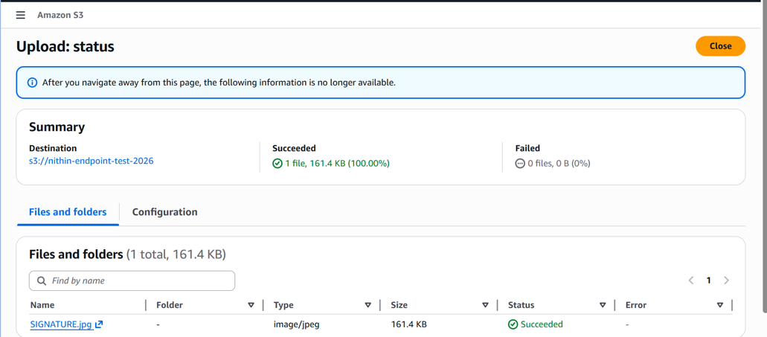
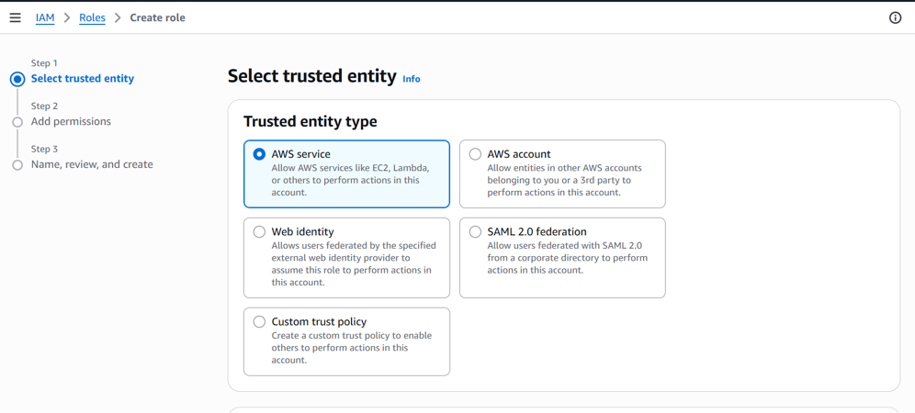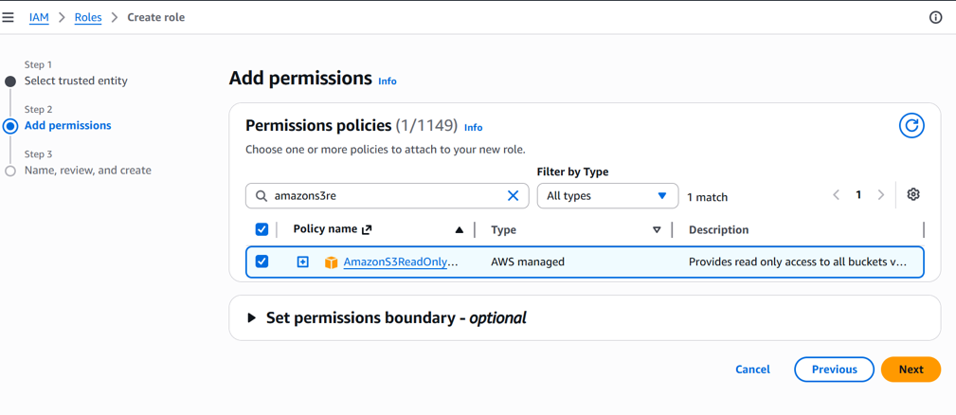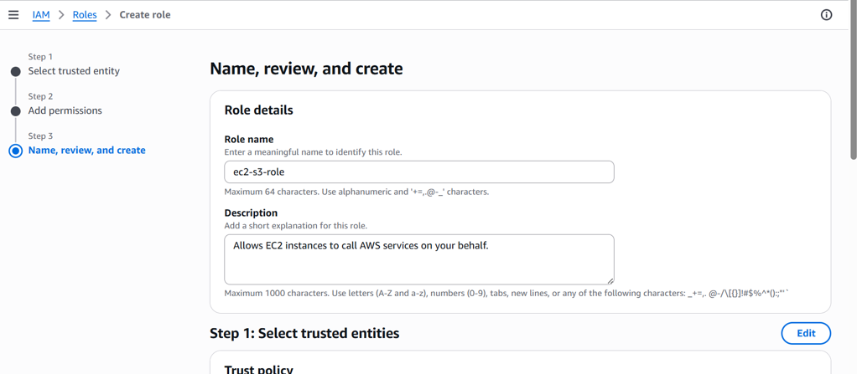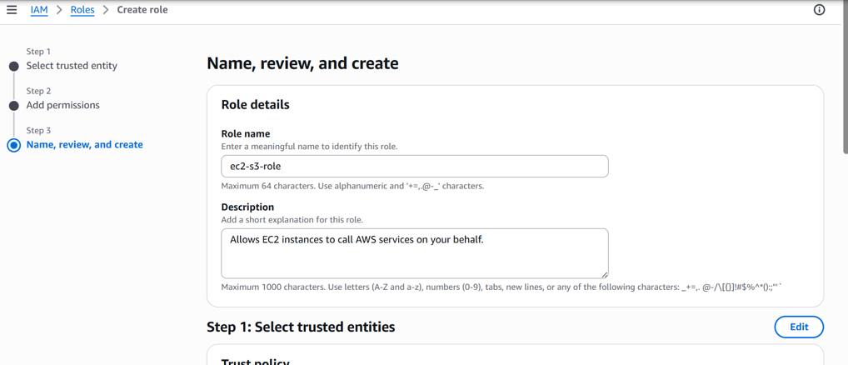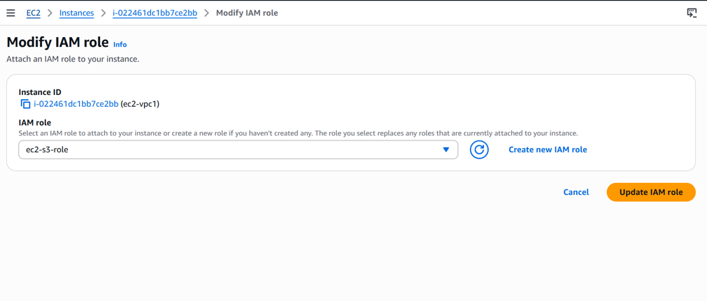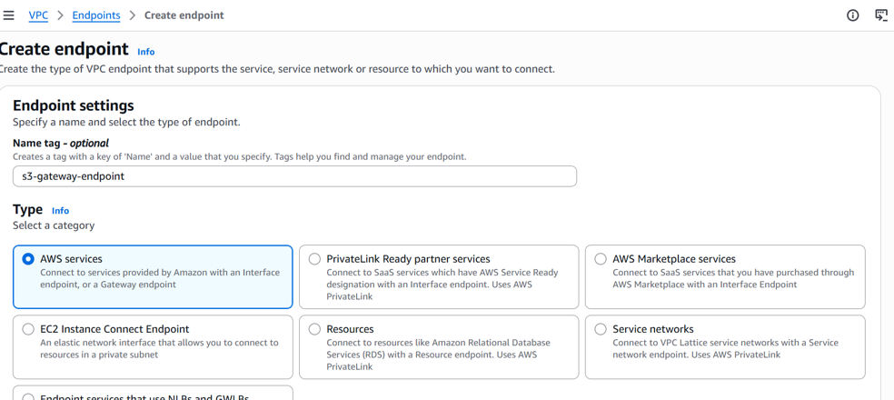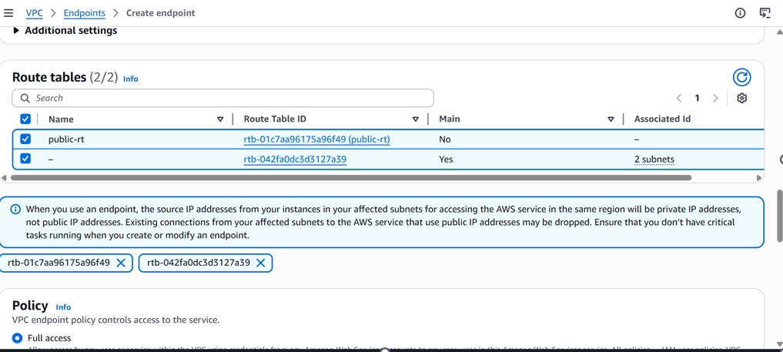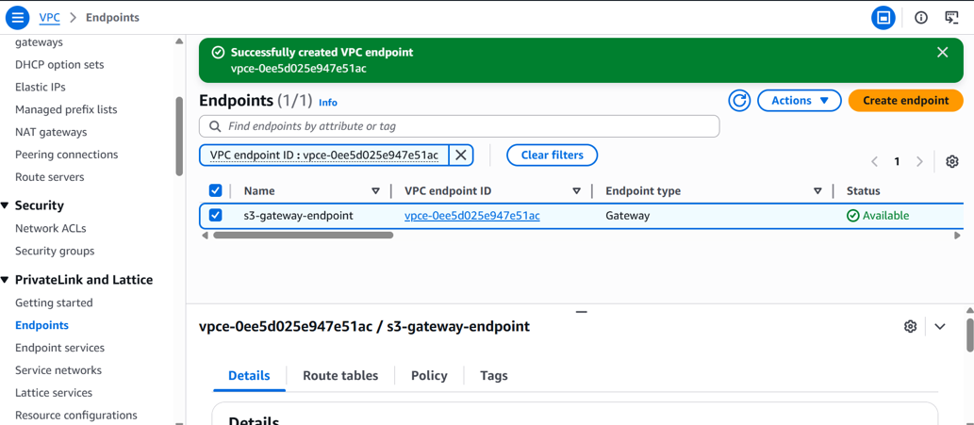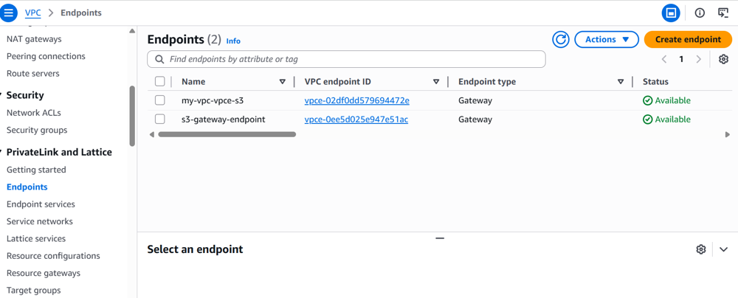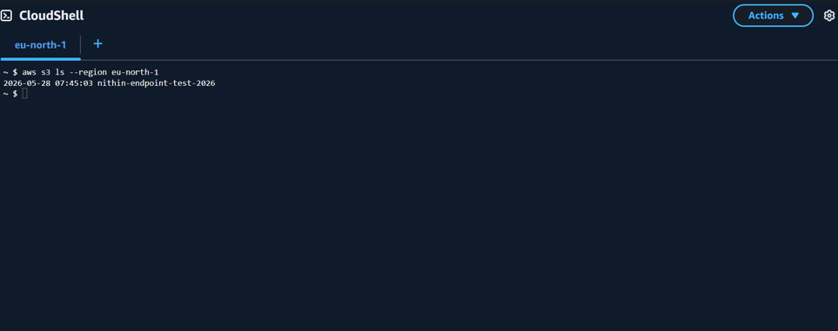
Validation Checklist
□ VPC Endpoint created — state = available
□ Endpoint type = Gateway, service = s3
□ Private route table shows auto-added S3 prefix list route
□ Private EC2 has NO public IP
□ Private EC2 has IAM role with S3 access
□ aws s3 ls works from private EC2
□ curl google.com FAILS from private EC2 (no internet)

